Day 2-Data Structures

1. #include <stdio.h>

#include <stdlib.h>

int main()

{

int size;

printf("Enter the size of the array: ");

scanf("%d", &size);

int *arr = (int *)malloc(size * sizeof(int));

if (arr == NULL) {

printf("Memory allocation failed.\n");

return 1;

}

printf("enter the %d elements \n",size);

for (int i = 0; i < size; i++)

{

scanf("%d",&arr[i]);

}

printf("Array elements: ");

for (int i = 0; i < size; i++)

{

printf("%d ", arr[i]);

}

printf("\n");

free(arr);

return 0;

}

Sample input-5

Output- 0,1,2,3,4

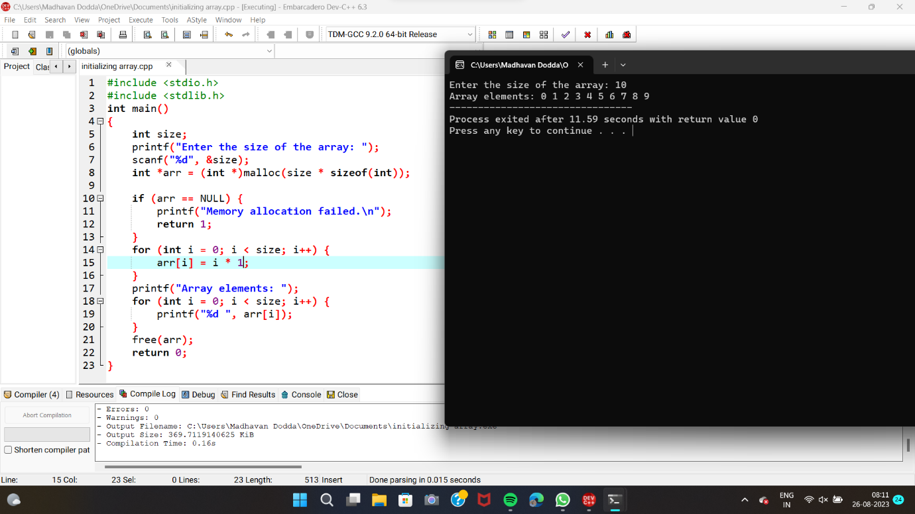

2. #include<stdio.h>

int main()

{

int size;

printf("enter the size of array");

scanf("%d",&size);

int arr[size];

printf("enter the elements of the array\n");

for(int i=0;i<size;i++)

{

scanf("%d",&arr[i]);

}

int sum=0;

for(int i=0;i<size;i++)

{

sum+=arr[i];

}

printf("sum of array elements %d\n",sum);

return 0;

}

Sample input-10

Enter the elements 1,2,3,4,5,6,7,8,9,0

Output 45

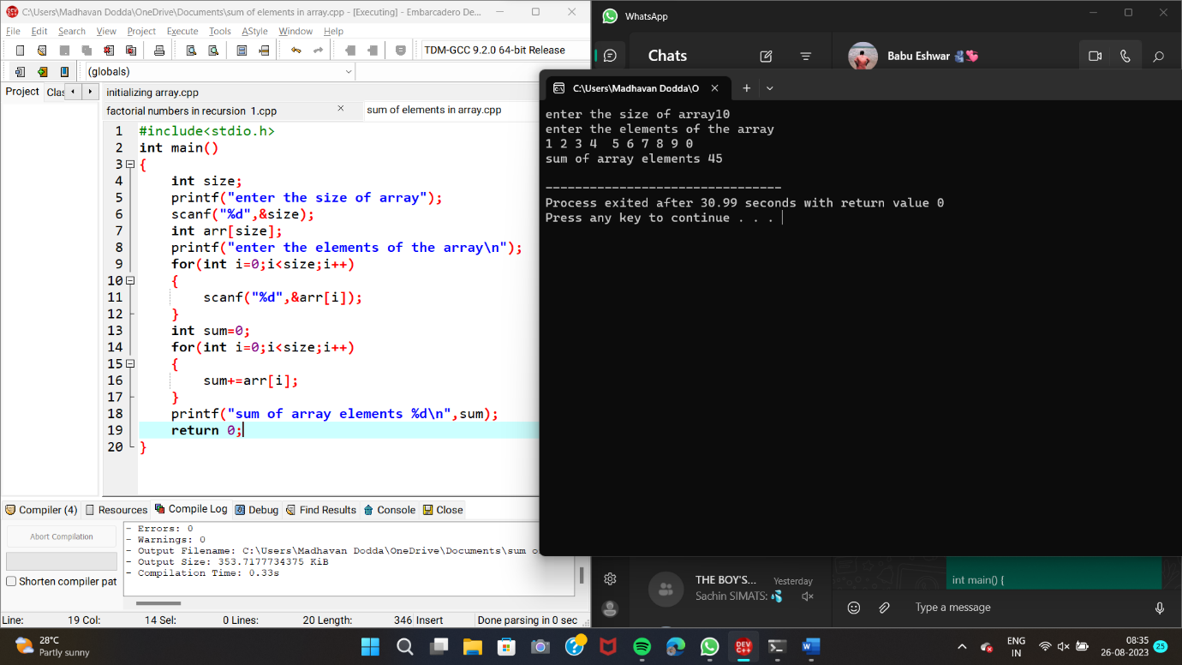

3.

#include<stdio.h>

int main()

{

int size;

printf("enter the size of the array");

scanf("%d",&size);

int arr[size];

printf("enter the elements of the array\n");

for(int i=0;i<size;i++)

{

scanf("%d",&arr[i]);

}

int sum_even=0,sum_odd=0;

for(int i=0;i<size;i++)

{

if(arr[i]%2==0)

{

sum_even+=arr[i];

}

else{

sum_odd+=arr[i];

}

}

printf("sum of even numbers=%d\n",sum_even);

printf("sum of odd numbers %d\n",sum_odd);

return 0;

}

Sample input-5

Enter the elements-2 3 4 5 6

Output

Sum of even =12

Sum of odd=8

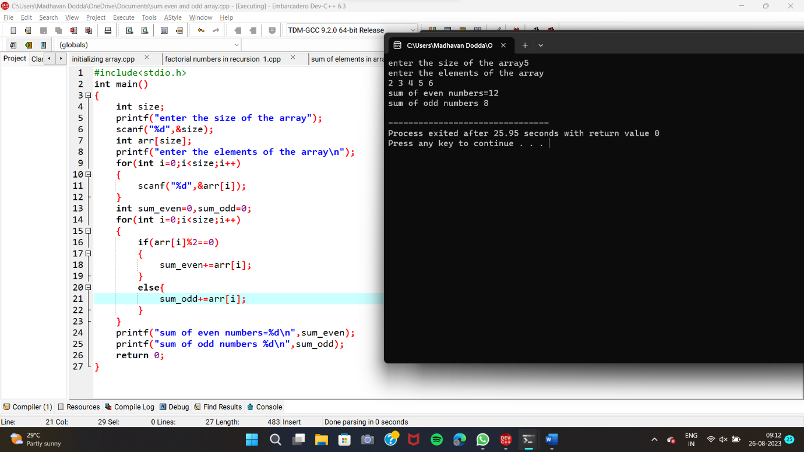

4. #include <stdio.h>

void display(int arr[], int size)

{

printf("Array elements: ");

for (int i = 0; i < size; i++)

{

printf("%d ", arr[i]);

}

printf("\n");

}

int main()

{

int size, choice, element, position;

printf("Enter the size of the array: ");

scanf("%d", &size);

int arr[size];

printf("Enter the elements of the array:\n");

for (int i = 0; i < size; i++)

{

scanf("%d", &arr[i]);

}

display(arr, size);

printf("Choose an operation:\n");

printf("1. Insert an element\n");

printf("2. Delete an element\n");

scanf("%d", &choice);

switch (choice)

{

case 1:

printf("Enter the element to insert: ");

scanf("%d", &element);

printf("Enter the position to insert: ");

scanf("%d", &position);

if (position < 0 || position > size)

{

printf("Invalid position.\n");

return 1;

}

for (int i = size - 1; i >= position; i--)

{

arr[i + 1] = arr[i];

}

arr[position] = element;

size++;

display(arr, size);

break;

case 2:

printf("Enter the position to delete: ");

scanf("%d", &position);

if (position < 0 || position >= size)

{

printf("Invalid position.\n");

return 1;

}

for (int i = position; i < size - 1; i++)

{

arr[i] = arr[i + 1];

}

size--;

display(arr, size);

break;

default:

printf("Invalid choice.\n");

return 1;

return 0;

}

}

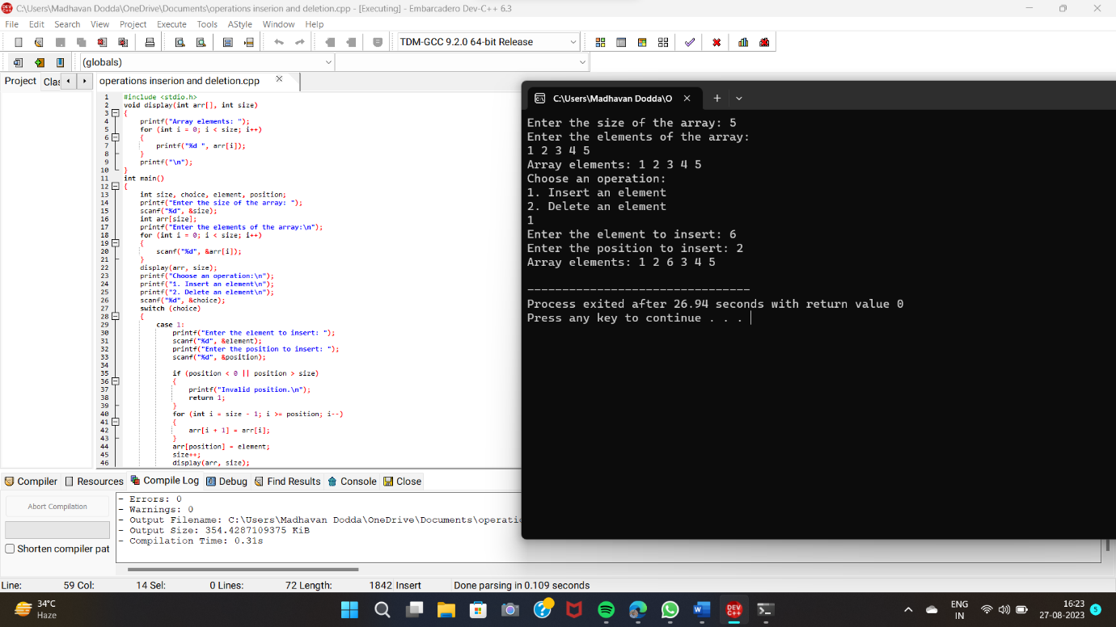

5. #include<stdio.h>

int main()

{

int n,m,i,j,o=0;

printf("enter the size of array 1:");

scanf("%d",&n);

printf("Enter the elements:");

int a[n];

for(i=0;i<n;i++)

{

scanf("%d",&a[i]);

}

printf("enter the size of array 2:");

scanf("%d",&m);

printf("Enter the elements:");

int b[m],k[m+n];

for(j=0;j<m;j++)

{

scanf("%d",&b[j]);

}

for(i=0;i<n;i++)

{

k[i]=a[i];

}

j=i;

for(i=0;i<m;i++)

{

k[j]=b[i];

j++;

}

for(int i=0;i<m+n;i++)

{

printf("%d ",k[i]);

}

return 0;

}

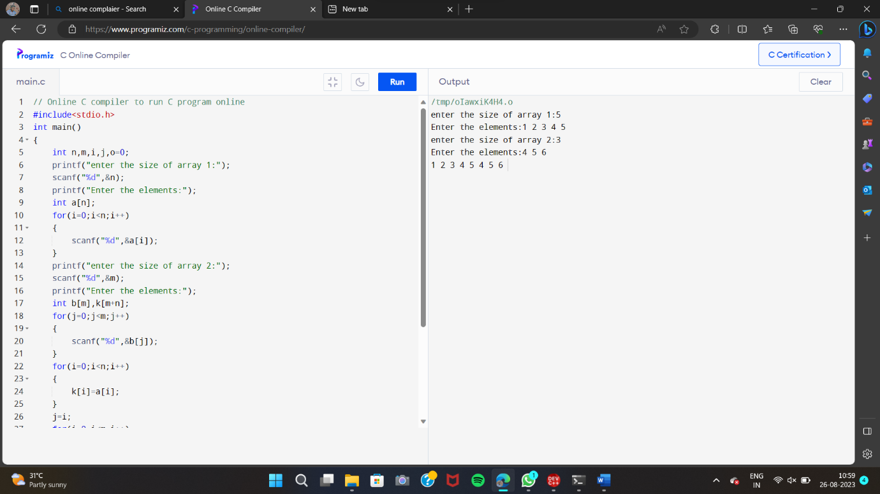

6. #include <stdio.h>

int main()

{

int size;

printf("Enter the size of the array: ");

scanf("%d", &size);

int arr[size];

printf("Enter the elements of the array:\n");

for (int i = 0; i < size; i++) {

scanf("%d", &arr[i]);

}

for (int i = 0; i < size - 1; i++) {

for (int j = i + 1; j < size; j++) {

if (arr[i] == arr[j]) {

printf("Duplicate value found: %d\n", arr[i]);

}

}

}

return 0;

}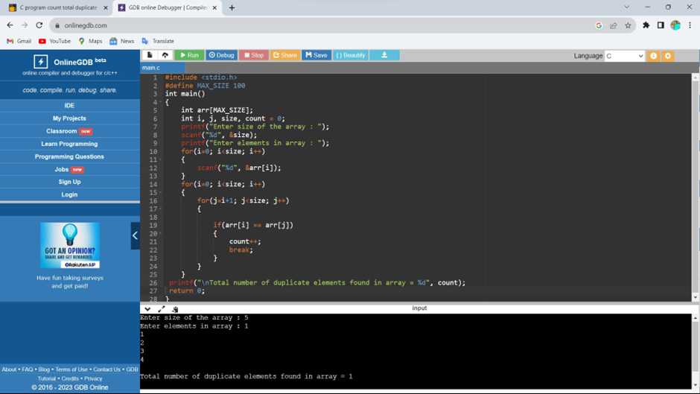

7. #include <stdio.h>

int main() {

int n;

double arr[100];

printf("Enter the number of elements (1 to 100): ");

scanf("%d", &n);

for (int i = 0; i < n; ++i) {

printf("Enter number%d: ", i + 1);

scanf("%lf", &arr[i]);

}

for (int i = 1; i < n; ++i) {

if (arr[0] < arr[i]) {

arr[0] = arr[i];

}

}

printf("Largest element = %.2lf", arr[0]);

return 0;

}

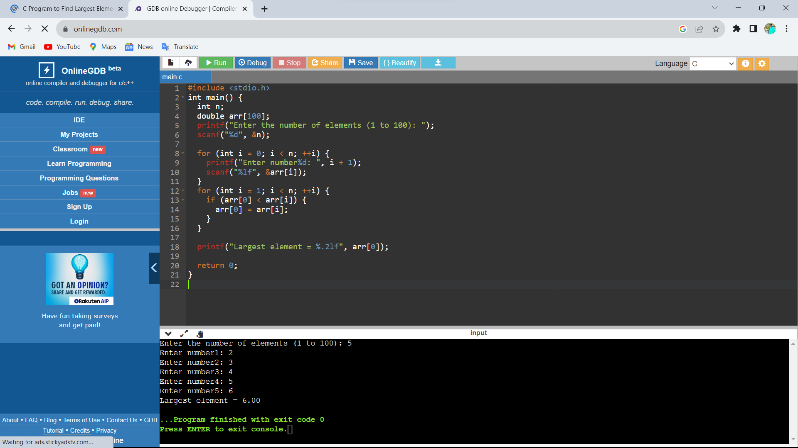

8. #include <stdio.h>

int main()

{

int array[100], search, c, number;

printf("Enter the number of elements in array\n");

scanf("%d",&number);

printf("Enter %d numbers\n", number);

for ( c = 0 ; c < number ; c++ )

scanf("%d",&array[c]);

printf("Enter the number to search\n");

scanf("%d",&search);

for ( c = 0 ; c < number ; c++ )

{

if ( array[c] == search )

{

printf("%d is present at location %d.\n", search, c+1);

break;

}

}

if ( c == number )

printf("%d is not present in array.\n", search);

return 0;

}

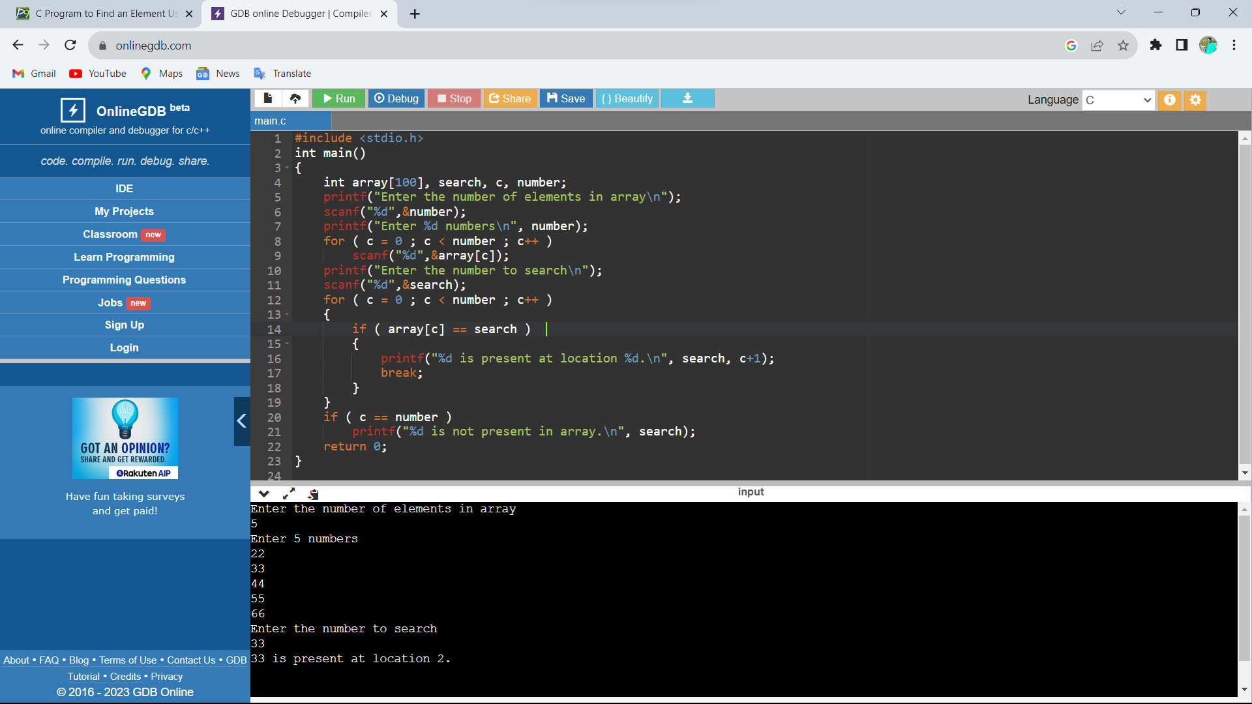

9. //Program Name: BinarySearch.c #include<stdio.h>

int main()

{

int c, first, last, middle, n, search, array[100];

printf("Enter number of elements\n");

scanf("%d",&n);

printf("Enter %d integers\n", n);

for ( c = 0 ; c < n ; c++ )

scanf("%d",&array[c]);

printf("Enter value to find\n");

scanf("%d",&search);

first = 0;

last = n - 1;

middle = (first+last)/2;

while( first <= last )

{

if ( array[middle] < search )

first = middle + 1;

else if ( array[middle] == search )

{

printf("%d found at location %d.\n", search, middle+1);

break;

}

else

last = middle - 1;

middle = (first + last)/2;

}

if ( first > last )

printf("Not found! %d is not present in the list.\n", search);

return 0;

}

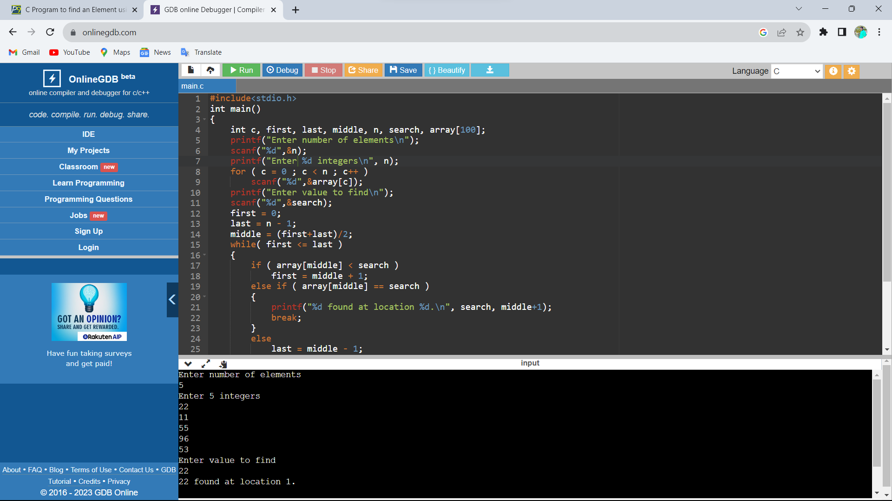

10. #include <stdio.h>

#include <string.h>

int main()

{

char s[100];

printf("Enter a string to reverse\n");

gets(s);

strrev(s);

printf("Reverse of the string: %s\n", s);

return 0;

}

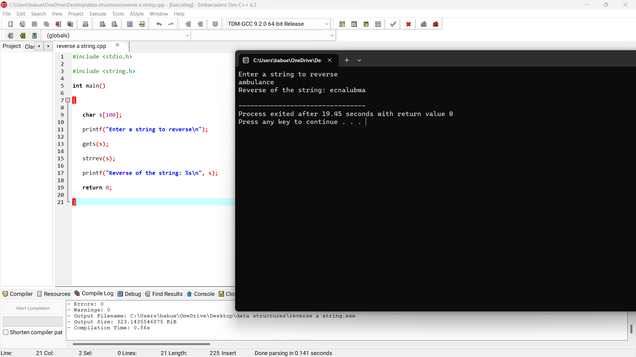

11. #include <stdio.h>

#include <string.h>

int main()

{

char s[1000];

int i,n,c=0;

printf("Enter the string : ");

gets(s);

n=strlen(s);

for(i=0;i<n/2;i++)

{

if(s[i]==s[n-i-1])

c++;

}

if(c==i)

printf("string is palindrome");

else

printf("string is not palindrome");

return 0;

}

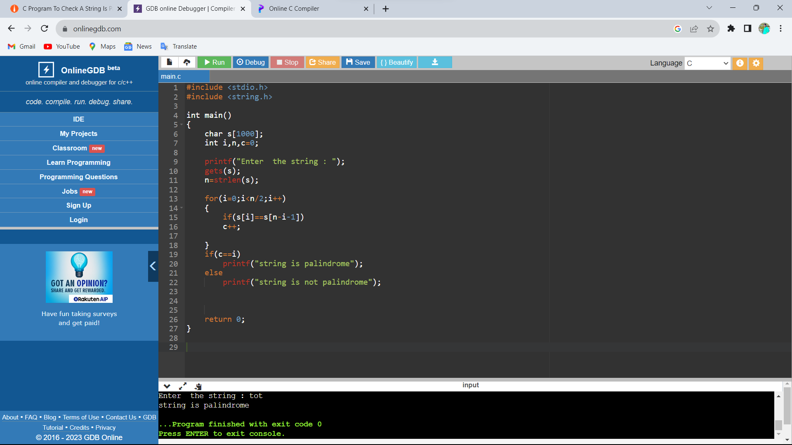

12.

#include <stdio.h>

#include <ctype.h>

int main()

{

char str[100];

int i, vowels = 0;

printf("Enter the string: ");

scanf("%[^\n]s",&str);

for(i = 0; str[i]; i++)

{

if(str[i]=='a'|| str[i]=='e'||str[i]=='i'||

str[i]=='o'|| str[i]=='u'||str[i]=='A'||

str[i]=='E'||str[i]=='I'||str[i]=='O' ||str[i]=='U')

{

vowels++;

}

}

printf("Total number of vowels: = %d\n",vowels);

return 0;

}

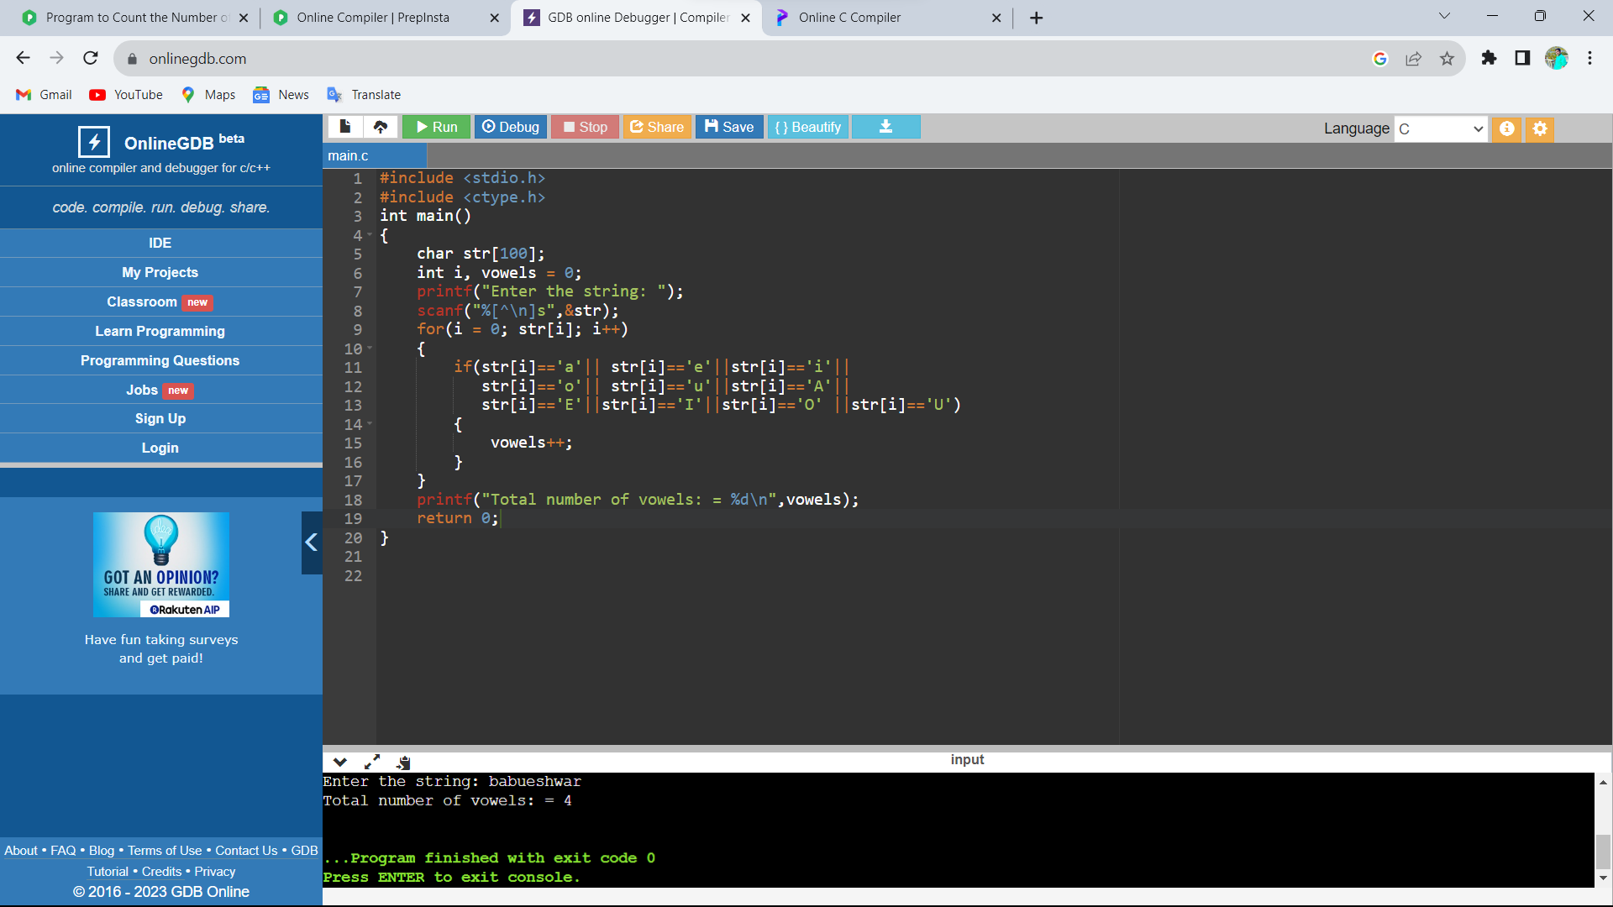

13. #include<stdio.h>

int main() {

int a[10][10], b[10][10], c[10][10], n, i, j, k;

printf("Enter the value of N (N <= 10): ");

scanf("%d", & n);

printf("Enter the elements of Matrix-A: \n");

for (i = 0; i < n; i++) {

for (j = 0; j < n; j++) {

scanf("%d", & a[i][j]);

}

}

printf("Enter the elements of Matrix-B: \n");

for (i = 0; i < n; i++) {

for (j = 0; j < n; j++) {

scanf("%d", & b[i][j]);

}

}

for (i = 0; i < n; i++) {

for (j = 0; j < n; j++) {

c[i][j] = 0;

for (k = 0; k < n; k++) {

c[i][j] += a[i][k] * b[k][j];

}

}

}

printf("The product of the two matrices is: \n");

for (i = 0; i < n; i++) {

for (j = 0; j < n; j++) {

printf("%d\t", c[i][j]);

}

printf("\n");

}

return 0;

}

